**Document**

**For Integrated Project 1 - M1I322997**

**Ghadeer Al Shehhi**

**National University of Science and Technology (College of Engineering)**

|  |  |  |
| --- | --- | --- |
| **File Name:** | Project Report | |
| **Document Owner:** | Osomah | |
| **Version:** | V1.0 | |
| **Document Status:** | Draft | |
| **Reviewed by:** |  | Date: 06-June-2020 |
| **Approved by:** |  | Date: |
| **Purpose of Document:** | Integrated Project 1 - M1I322997 | |

**Change History**

|  |  |  |  |  |
| --- | --- | --- | --- | --- |
| **Version** | **Date** | **Revised By** | **Section Modified** | **Description** |
| 0.1 | 06-June-2020 | Ghadeer Al Shehhi | All | Initial version |

Contents

1. Introduction 6

1.1 Overview 6

1.2 Objectives 6

1.3 Purpose and scope of the project 6

1.4 Functional & Non Functional Requirements 6

1.5 Business Case for the Proposed System 7

1.5.1 Reasons for the project 7

1.5.2 Business Options (do nothing, do the minimal) 7

1.5.3 Expected benefits 7

1.5.4 Cost, Time Scale and Major Risk 7

2. Solution 8

2.1 Design of Databases (E. R Diagrams) 8

2.2 Data Flow Diagrams 8

2.3 Use Case Diagrams 8

2.4 UML Diagrams 8

2.5 Interface Design Diagrams 8

3. Implementation Details 8

3.1 Software Life Cycle Used 8

3.2 Database and Tables used 12

3.3 Describing important SQL statements used 14

3.4 testing the form with entered data 15

4. Results & Discussion 18

5. Conclusion 18

6. Future Work 18

Abstract

Computers have become a lifestyle for the present high society.If there were no computers, many areas of modern life that we have come to accept as common knowledge would not be possible. Today's computers are used widely in many fields of business, manufacturing, research, education, etc. The computer's main advantage is its speed, which makes it quite easily able to provide some useful information. The speed also opens new solutions to existing problems.Although the computers do only what is instructed in anyway times, these instructions are taken into account and accurate information is generated. Computer can hold data and instructions in system storage inside an electronic version, and this data can be retrieved at any time. Our project entitled “Super Store Management System” is complete software package which can be used in real life business for managing clients, employees, available stocks and Super Store orders. By using this software, we can easily automate the whole process of a Super Store. This system consists of four different modules to facilitate the business.

* Customer Module
* Home Page Module
* Employee Module
* Place Order Module

To briefly explain module, first we have customer module, this module responsible for adding new customers as we believe that customer come first in our business and it is customer which can provide us the money for our business. We have some special emphasis to this module, other feature set includes searching, updating and deleting the users.

The Home Page Module is responsible for adding new store’s items enhancing our stocks, removing updating and searching are also the part of this module.

Here, we have a strong believe that if in any business if you take care of your employee then it will have positive impacts on the business. In this module all the recordsare maintained in a precise and professional manners. This module has four properties of adding, updating, searching and deleting the record for the employees.

The last module named place order module having the search, delete, insert and update option. In upcoming section of this document we will have a walkthrough of this system in detail. This system is developed in vb.net 2017, the system is menu driven and user-friendly and will help its user while operating on this system. For back end or the database, we have used the “*SuperStoreManagementSystem.mdf*” file.

# Introduction

## Overview

In this project I have made an attempt to design the software for Super Store that makes the management of recoding the employee details, customers, placing an order and add store’s items much easier. The main objective of this system the maintain all the record in prices and hazard less manner. I believe this system will facilitate each and every kind of user in Super Store business.

## Objectives

The software powered by vb.net 2017 assure clear and efficient services, the easy to operate system helps to access and modify the employee, store’s items, order placing and customer records. Super Store management system is design to provide error free and reliable information in minimum possible time. To ensure enhanced security employee or customer record creation, editing, etc. are available only at the administrator, to use this Super Store management system the username and password “admin”, “admin”.

## Purpose and scope of the project

For real time implementations I have limit the scope of this software system to only four necessary modules of super store business, although I can add further modules in this system. The system 100% flexible and extensible for addition of new development and feature sets.For example, a new module for auditing can be used and the purpose would be to track all the changes for adding critical information. Other module like reporting of daily sale can be added. The main purpose of this system the maintain all the record in efficient, prices and professional manner.

## Functional & Non Functional Requirements

Some of the functional requirements for this projects are it should be developed based on the business rules such as addition, searching, modification and deleting. All this requirement come under the functional requirement of Transaction corrections, adjustments, and cancellations. Without password or authentication nobody should have the access to the system.

To fulfil the non-functional requirements, this system 100 capable to comply with the following non-function requirements.

* Performance – for example Response Time.
* Scalable.
* Available.
* Reliable
* Recoverable
* Maintainable.

## Business Case for the Proposed System

I have conducted a proper research in the current market of super store business and based on my research I have finalize, this software should have these four modules as discussed earlier in abstract section. What I believe is that I should record each and every thing in this software related to Super Store business.

### Reasons for the project

Based on my research I noticed that Super Store industry lacks in taking the humongous advantages of today computers system.

### Business Options (do nothing, do the minimal)

Department stores carry a wider variety of merchandise than most stores but offer these items in separate departments within the store. These departments usually include home furnishings and household goods, as well as clothing, which may be divided into departments according to gender and age. Department stores in western Europe and Asia also have large food departments, such as the renowned food court at Harrods in the United Kingdom. Departments within each store are usually operated as separate entities, each with its own buyers, promotions, and service personnel.

### Expected benefits

Initially, the development of the full software will cost high but it will minimize the manual intervention of human in long run, which will ultimately save a lot of money.

### Cost, Time Scale and Major Risk

In start to software development may cost but in long run it will save both time and money and will automate the task which were previously done manually, plus computer don’t became sick or they don’t take leave and they don’t get married as well. The only risk is that no un-authorise person access to the sensitive data.

# Solution

While developing this project I have followed software develop life cycle (SDLC) and the first phase is system analysis, which consists finding out what happens in existing system and deciding on what to change and what kind of new feature should be added in the proposed system, I have done all the task in analysis manually as presently there are no specialized software record all the steps in this phase. To summarize, the analysis I realized that we need a software system for Super Store management system, and the purpose of the system is to automate the Super Store business. Software must record all the details related to employee records, customers record, Super Store and order placement records.

## Design of Databases (E. R Diagrams)

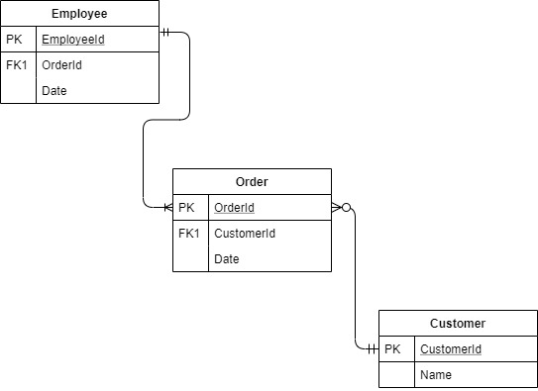

## 

## Data Flow Diagrams

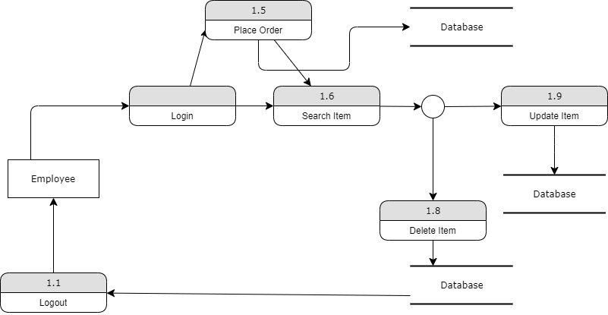

## Use Case Diagrams

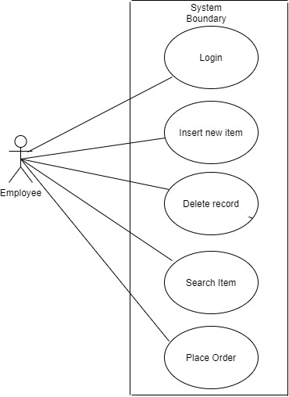

## UML Diagrams

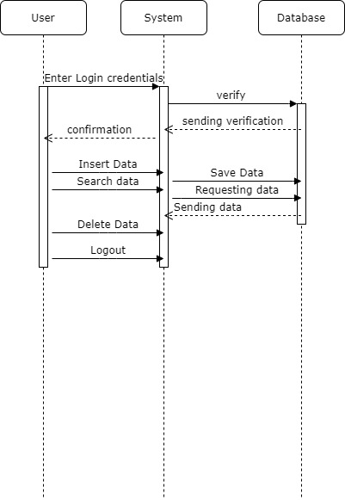

## Interface Design Diagrams

Provided in section 3.4.

# Implementation Details

## Software Life Cycle Used

I have used the waterfall model for developing this strategy as shown below.

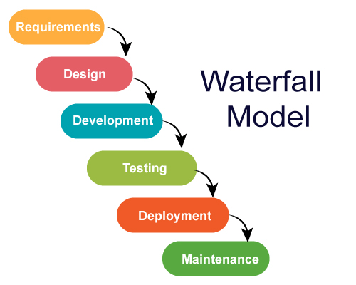

**Figure 1: Water Fall Model**

## Database and Tables used

In this software I have used four different tables for saving the data, as shown below.

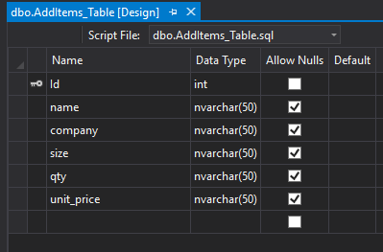

**Figure 2: AddItems_Table**

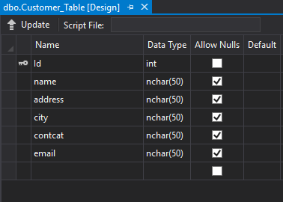

**Figure 3: Customer_Table**

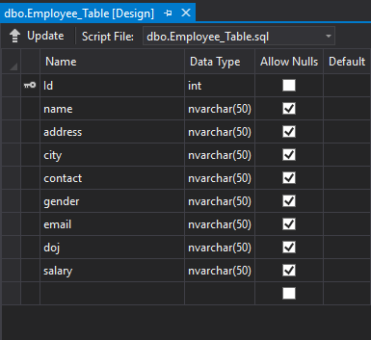

**Figure 4: Employee_Table**

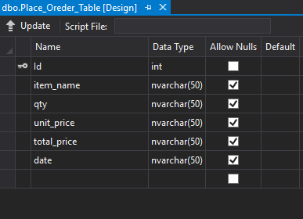

**Figure5: Place_Order_Table**

## Describing important SQL statements used

Though, I have used so many different SQL statements, but here I will mention only four.

1. Insert customer data, for this I have used the following query.

*sql = "insert into Customer_Table values ("&id.Text&", '"&custName.Text&"', '"&address.Text&"', '"&city.Text&"', '"&contact.Text&"', '"&email.Text&"')"*

1. Search customer data based on different parameters, for this I have used the following query.

*sql = "select * from Customer_Table where name = '"&custName.Text&"'”*

1. For delete Customer Information based on name, I have used the following query.

*sql = "delete from Customer_Table where name = '"&custName.Text&"'"*

1. To modify customer data based customer name, I have used the following query.

sql = "delete from Customer_Table where name = '" & custName.Text & "'"

## Testing the Forms with entered data

I have test all the forms one by one, thoroughly. Here I will provide only five screen shots for understanding, the rest are available in code.

**Figure6: Login Screen**

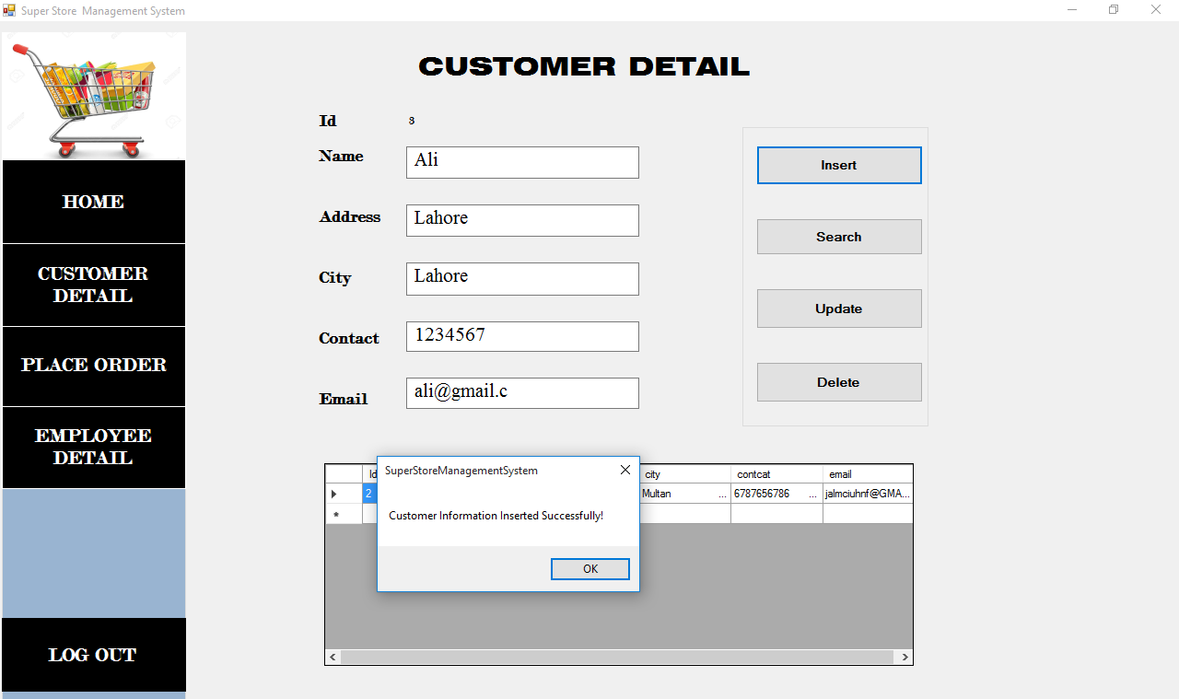**Figure 7: Customer Detail Screen**

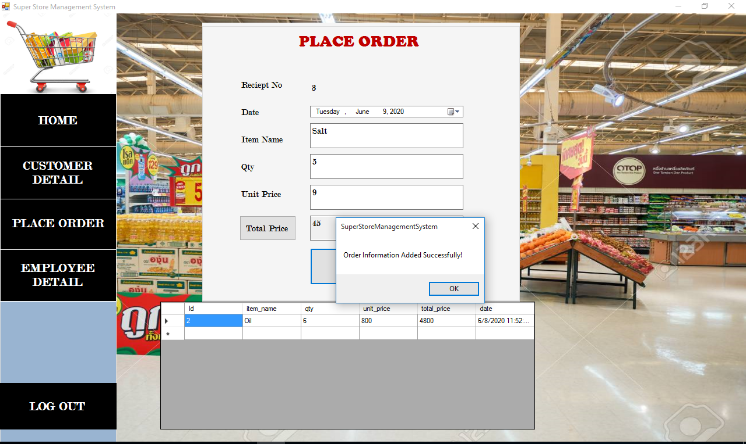

**Figure 8: Place Order Screen**

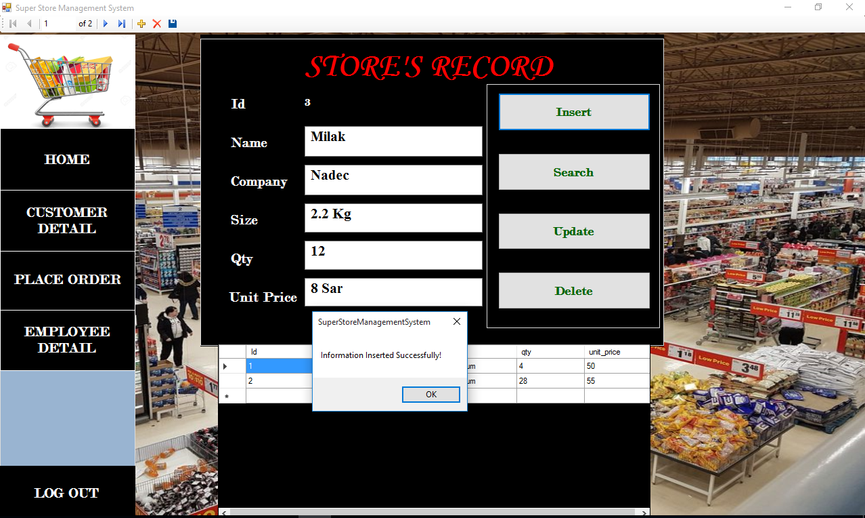

**Figure 9: Add Items Home Screen**

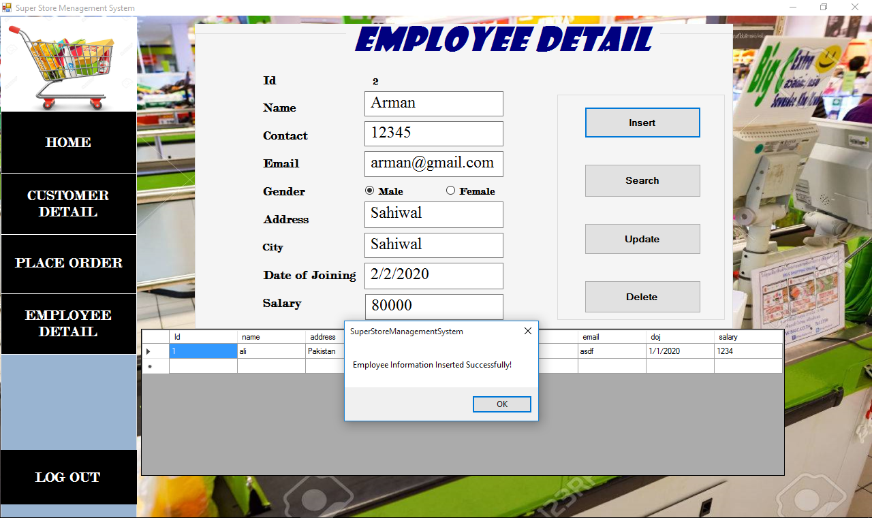

**Figure10: Employee Detail Screen**

# Results & Discussion

* This system gives better feedback.
* Chances of error are much low.
* Every process takes minimum possible time.
* The system run with great speed.
* Every form is user friendly.
* Easy to operate on this system.
* Accurate information are available in the system.

# Conclusion

# We are confident that this Super shop management software system specification for the real-life Customer service refers to a departmental Super shop ability to satisfy of the management of supper shop needs.

# Future Work

Although I have added four different modules, but still there can be added multiple features in this project some of them are listed below, there may be more.

* Auditing Module
* Online Order System
* Addition for other languages
* Reporting for daily, weekly and monthly sale
* Printing of every sales order